Assignment 2: Difference Between TDD and BDD

Test Driven Development (TDD) and Behaviour Driven Development (BDD) are two software development methodologies, each with a different focus and approach. TDD concentrates on writing tests before writing the actual code. The process begins with writing a test case based on the expected technical output, then running the test to see it fail, writing the code needed to pass the test, and finally refining the code. TDD helps in improving code quality, reducing bugs, and ensuring that every piece of code has a specific purpose.
On the other hand, BDD focuses on how the application should behave from the user’s perspective. Instead of writing tests in technical language, BDD uses simple English sentences to describe real user scenarios using the “Given–When–Then” style. This makes it easy for developers, testers, and business stakeholders to collaborate. After the behaviour is described, automated tests are written based on these scenarios, and then the code is developed to satisfy the expected behaviour.
Both TDD and BDD aim to improve software quality but differ in their approach. TDD is more technical and best suited for backend logic, algorithms, and internal functions. BDD is more user-focused and is ideal for features like login, search, shopping cart actions, or any process involving user interaction. TDD ensures correctness of the code, whereas BDD ensures correctness of the user experience.

TDD Example: Learning to Shoot a Basketball
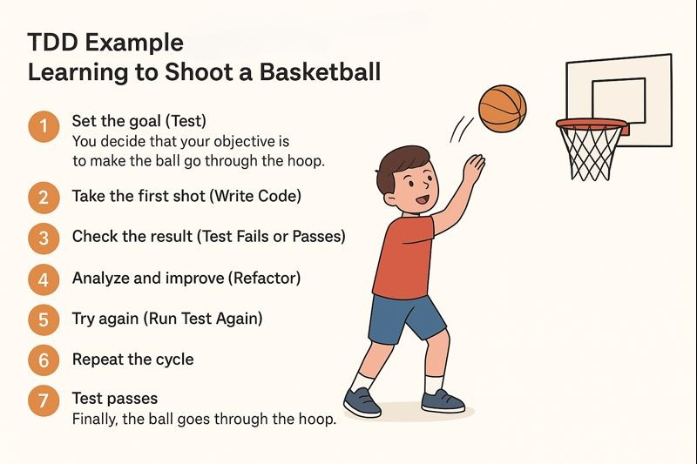
- Set the goal (Test):
You decide that your objective is to make the ball go through the hoop. This is like writing the test first.
- Take the first shot (Write Code):
You attempt to shoot the ball based on your current understanding and technique.
- Check the result (Test Fails or Passes):
The ball misses the hoop. This means the “test” has failed.
- Analyze and improve (Refactor):
You adjust your position, change your aim, modify your hand movement, or adjust the force used.
- Try again (Run Test Again):
You shoot the ball again to see if the changes work.
- Repeat the cycle:
You keep testing and improving—shoot, fail, correct, shoot again.
- Test passes:
Finally, the ball goes through the hoop. This means the target is achieved and the “test” passes.
BDD Example: Ordering Food at a Restaurant

Behaviour comes first → then action.
In points (simple language):
- Describe the behaviour in everyday language
“As a customer, I want to order food so that I can eat what I like.”
- Write scenarios before doing anything:
Scenario:
  - Given I am hungry
  - When I tell the waiter “I want a pizza”
  - Then I should receive the correct pizza
- Everyone (chef, waiter, customer) understands the same rules
→ This is like developers, testers, and product team agreeing on behaviour.
- Only after behaviours are clear, the process starts
  - Waiter takes order
  - Chef cooks it
  - Food is served exactly as described
- If behaviour changes, steps change
Example:
“If I say no cheese, I should get pizza without cheese.”

